Project Design Phase-I
Solution Architecture

Date | 8 February 2026
Team ID | LTVIP2026TMIDS61992
Project Name | visualization tool for electric vehicle charge and range analysis
Maximum Marks | 4 Marks

Solution Architecture Diagram:

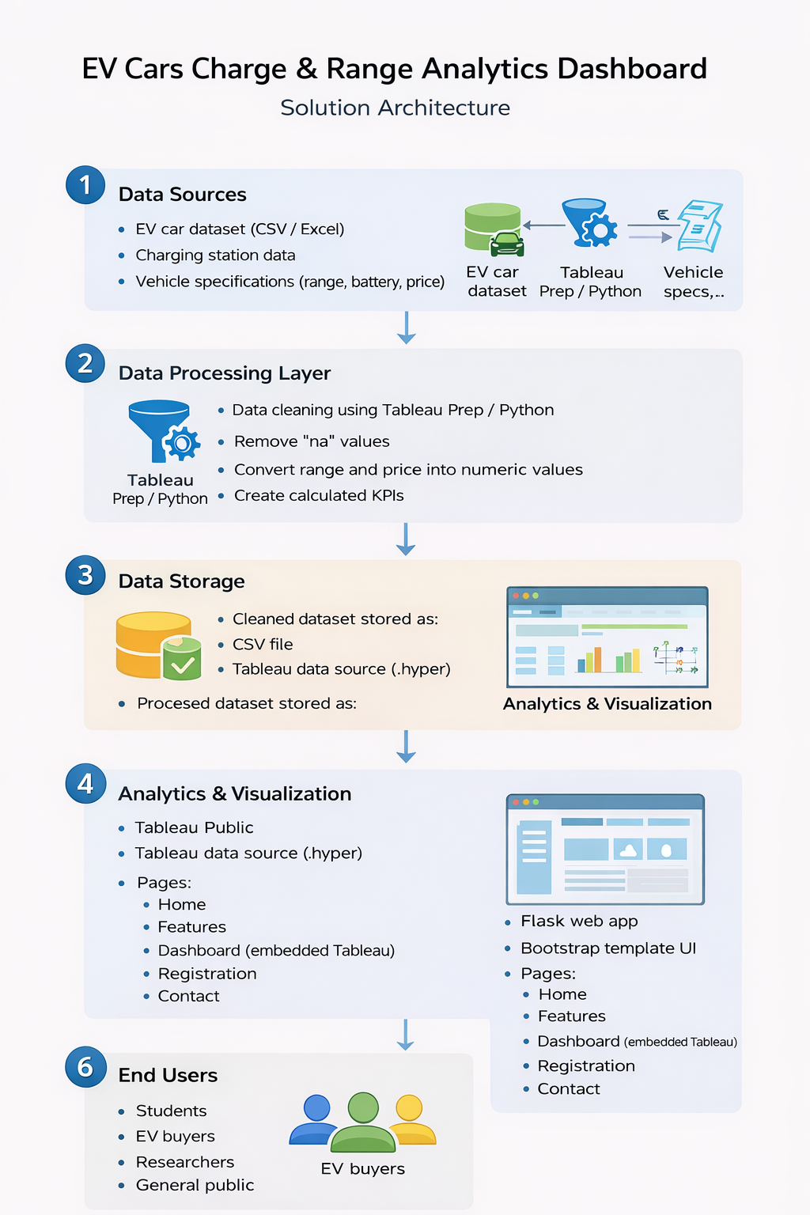
Figure 1: Architecture

